Dr. Rick Sylves
Office 459 Smith Hall
Office Hours: 3:30-5:30 pm Tuesdays and Wednesdays,
and, by appointment.
Phone: 831-1943 (accepts voicemail)
Fax: 831-4452 (Be sure “Sylves” appears on sent cover sheets)
Email sylves@udel.edu
Fax (302) 831-4452 (please email Prof. Sylves via course WebCT emailing only)

This is the syllabus as of August 29, 2007. Watch for revised versions. When you are apprised of a revised version it is your responsibility to print and use the latest version.
POSC 456, Fall 2007
Politics and Disaster
(Undergraduates Only)
Go to www.udel.edu/webct/ and login in to get to web page for this course

1. Overview

On August 28, 2005, a Category 5 hurricane named Katrina bore down on the Louisiana-Mississippi Gulf Coast and ultimately brought catastrophe for New Orleans and the region. We are at the second anniversary of this disaster. We will examine this disaster and many others. American homeland security encompasses disasters of all types, not just terrorism.

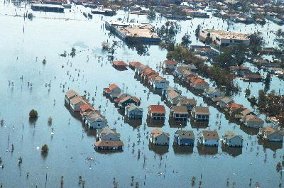

The terror attacks of September 11, 2001 changed the world, especially for the United States. While there have been terror attacks on the U.S. in the past, 9/11 surpasses by far the scale of devastation of any attack on the U.S. “homeland” since Pearl Harbor in 1941.
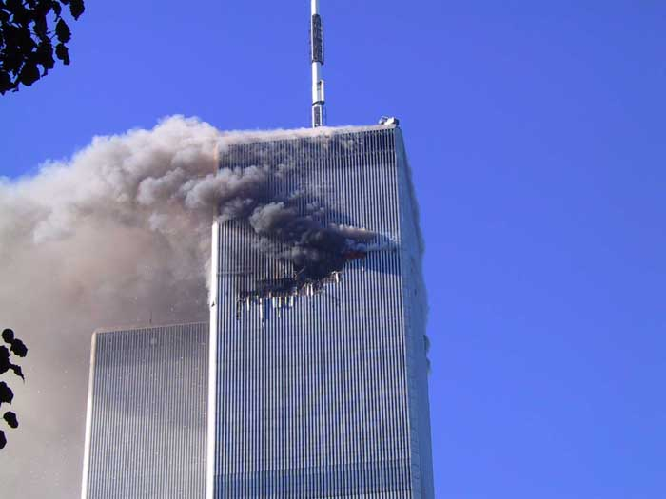

Some have called 9/11 the most devastating terrorism attack ever, but it may be safer to call this the most devastating terrorism attack ever on the U.S. The 9/11 attacks required application of domestic emergency management because the events of that day involved “terrorism consequence management,” in official parlance. This course will examine “terrorism consequence management” as well as U.S. disaster management and policy more broadly. This course will also take up issues surrounding “Homeland Security.” The image below is from an ad for Oliver Stone’s World Trade Center movie.

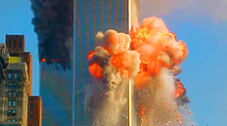

I can avoid disappointing you if I define the scope of this course at the outset. This course concerns United States experience (domestically and internationally) with disasters over the last 50 years but thanks to the Coppola book, we will also examine international disaster issues as well. Public policy, public management, global governance, and politics are central to understanding how we will take up the subject. This course is about NATURAL AND HUMAN-CAUSED DISASTERS THE U.S. NATIONAL GOVERNMENT HAS COME TO ADDRESS IN LAW AND POLICY. The course also considers that the concept of disaster is in many ways politically and socially constructed. This will be explained over the semester.

Acts of terrorism hold the potential to be disasters and so are included in this course. However, TERRORISM IS NOT THE EXCLUSIVE SUBJECT OF THIS COURSE. This course does NOT duplicate courses the Political Science and International Relations department offers on comparative politics, political culture, international relations, migration and political terrorism. Professor Kaufman teaches POSC 415, Force and World Politics and that course may interest those who want an international focus exclusively. Likewise, Professor Khan offers POSC 377, Arab-Israeli Relations and that course may be of interest to you as well. Prof. Miller is a renowned expert on immigration policy and he has made the study of terrorism part of his field of expertise. This course addresses in limited ways disasters outside America, but the focus of the course is on U.S. disaster policy, politics, emergency management, and homeland security.

America has a long history of disaster. This course examines modern laws, programs, agencies, and institutions involved in U.S. disaster policy and emergency management. The president is a key player and Congress has major responsibilities in this realm as well. State and local governments are also important, as are a variety of private and non-profit organizations that are stakeholders in this realm. The vast majority of American disasters stem from “natural sources,” and so the course has to address hurricanes, earthquakes, floods, major fires, tornadoes and a variety of other natural disaster agents. However, this course includes “human-caused” disasters, including terror disasters. America experienced terrorism before 9/11.

This is a course Prof. Sylves designed himself in 1988. He has been the only instructor of this course since that time. “Disaster and Politics” became a permanent course offering at UD in 1991. Since 1988, Prof. Sylves has taught the course twelve times and he last taught this course in fall 2006.

Prof. Sylves changes books and articles each time he teaches the course. Prof. Sylves has published three books, two of them on Disaster Policy and he has a fourth under contract with CQ Press and a fifth under contract with Elsevier. Many classes involve reading assignments from Sylves’ own publications and draft research work (provided to you free as photocopies or WebCT Postings you can print out).

From 1996-2000, Sylves did work on two higher education projects under grants from the U.S. Federal Emergency Management Agency. He tailored his work as a training instrument and but he is not going to directly use this work. Sylves’ major project for FEMA was called the Political and Policy Basis of Emergency Management. His second FEMA project grant addressed the Economic Dimensions of Disaster. Sylves also produced a 300-page research report for the U.S. National Oceanic and Atmospheric Administration’s Sea Grant program in the late 1990s about presidential disaster declarations. From January 2002 to August 2005, Dr. Sylves has served as an appointed member of the National Academy of Science Disaster Roundtable, a group that sponsors three workshops a year in Washington, D.C. on disaster related subjects (Disaster Roundtable at www.nationalacademies.org/dr )

Sylves’s forthcoming book is entitled DISASTER POLICY AND POLITICS. He is interested in soliciting your opinions and constructive criticism of this book because the book is aimed at students exactly like you. He suspects that you can learn a great deal about current disaster policy and politics from the draft chapter work he will share with you. However, the bulk of the readings in this course were written by others.
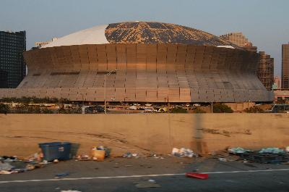

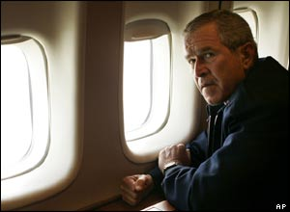

2. Books

Most books listed below are available at the University Bookstore. If any sell out let me know immediately.

Required:

Birkland, Thomas A. Lessons of Disaster: Policy Change After Catastrophic Events. Washington, DC: Georgetown University Press, 2007.

Coppola, Damon P. Introduction to International Disaster Management. Boston, MA: Elsevier, Butterworth-Heinemann, 2007.

Haddow, George D. and Bullock, Jane A. Introduction to Emergency Management. 2nd Edition. New York: Butterworth-Heinemann, 2006.

Kettl, Donald F. System under Stress: Homeland Security and American Politics. Washington, DC: CQ Press, 2007.

Miskel, James F. Disaster Response and Homeland Security: What Works, What Doesn’t. Westport, CT: Praeger Security International, 2006.

Optional:

Badey, Thomas J. Ed. Violence and Terrorism: Annual Editions. Dubuque, IA: McGraw-Hill Contemporary Learning Series, 2007.

Watch for items posted on the course web page as there will be many over the course of the semester. These are intended to bring you up to date on what is going on in this field.

3. Why a Course on Disaster and Politics?

You might ask yourself, why disaster and politics? Is the phenomenon we call “disaster” a social constructed one? What is emergency management? What is important about disaster policy? What defines a "disaster"? Can I get a job if I know this stuff? Doing what? Why does government care about disaster? Which levels of government prepare for and respond to disaster and how do they do it? How is disaster policy similar to (or different from) housing policy, energy policy, environmental policy, transportation policy, etc.? What is homeland security policy and how does it relate to disaster policy and politics? Are there good academic studies of disasters, if so by whom and what did they demonstrate? Can governments avert disasters or make them less destructive? Who pays for disaster response and recovery? Why should the nation care about a disaster that only affects a tiny fraction of the land area of the country? Why do government leaders care about disasters that occur outside the United States? Are major disasters increasing or decreasing in frequency? How is the international community organizing to address disasters?

More topically, how and why did disaster policy and management fail in the days after Hurricane Katrina devastated the central Gulf Coast and after the levees surrounding New Orleans failed? Does disaster management have political implications? What does disaster relief and rebuilding say about the United States as a nation and as a political culture?

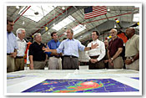

"Lotsa" questions!

I will, helped by you, answer most if not all these questions in this course. For most of you this course must seem like an alien subject. You should know that you are not "warped" for having an interest in this field. Disaster is a subject of increasing domestic and international interest: Katrina and 9/11/ certainly underscore this claim. There are several possible reasons for this.

First, since 1989 the United States has experienced a sizable increase in the number and expense of its natural disasters. Until 9/11 and Katrina, Hurricane Andrew in 1993 and the Northridge California earthquake of 1994 were the nation's most expensive “concentrated” disasters in the last half-century. Add to this the EXXON Valdez oil spill in 1989, the Murrah Federal Office Building bombing in Oklahoma City in 1995, New York's first Twin Towers disaster in 1993, and a host of other calamities, like the 1993 Great Midwestern floods, and finally 9/11/01 & Katrina and you are going to get people's attention. Even forgettable Hurricane Charley, which impacted a wide swath of Florida in August 2004, caused many billions in damage. Hurricane Katrina may well end up being the nation’s most expensive natural disaster.

Below is the Exxon Valdez oil tanker which released a mammoth oil slick in Alaska’s Prince William Sound in March 1989.

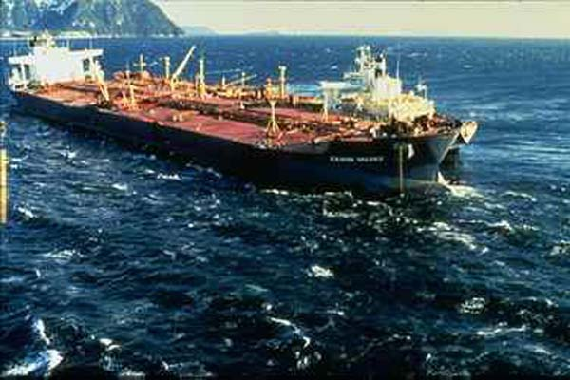

Below is a photo of the Murrah Federal Office Building in Oklahoma City, destroyed by Timothy McVeigh and associates, in the spring of 1995, with 187 fatalities.

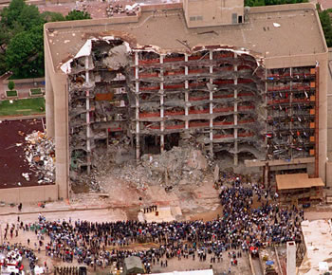

Below is a photo of a so-called staging area for emergency responders seeking to get to people trapped at the Super Dome and Convention Centers in New Orleans.
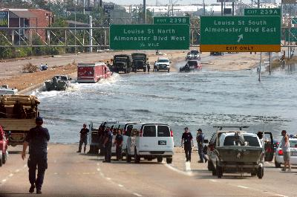

Hurricane disaster losses alone are now so immense that any hurricane that makes landfall in the U.S. is expected to produce at minimum a billion in losses. Billion dollar disasters before 1990 were extremely rare. Billion dollar disasters since 1990 now occur two or three times a year, or more. Clinton era disaster managers alleged that disaster losses to the full American economy were running at $1 billion a week.

Second, since the end of the half-century long Cold War between the U.S. and the U.S.S.R., many governments, treaty organizations (previously based on defense), and the United Nations have come to attach more importance to the humanitarian role of the international community in addressing people's needs in the aftermath of disaster. Sometimes disasters stem from nation-to-nation wars, civil wars, or "domestic strife (Darfur)." Today Iraq, Afghanistan, and the Darfur region of the Sudan and previously Bosnia, Kosovo, Haiti, Somalia, Rwanda, Burundi, Ethiopia, and other countries all have suffered, or are suffering, forms of disaster. Indonesia and Ceylon suffered catastrophic coastal damage from the tsunami of Dec. 26, 2004 and upwards of 250,000 lives were lost. Bangladesh seems to suffer recurring flood and monsoon disasters that kill tens of thousands of people.

Below is an eerie photo of the aftermath of the South East Asia tsunami disaster, an event that killed an estimated 300,000 people and which occurred Dec. 26, 2005.
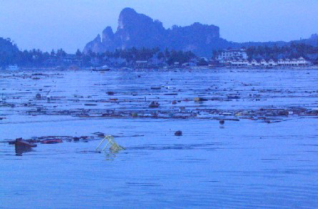

As an example of variation in quake devastation consider that the "World Series Earthquake" which took place just before the start of a World Series game in San Francisco in 1989 killed about 65 people; not long after this a quake of comparable magnitude in Soviet Armenia killed 25,000 people. The last truly catastrophic earthquake in China killed over 200,000 people. Japan's Kobe earthquake not long ago demonstrated that even developed, economically wealthy countries suffer disasters and often need outside help. Some 5000 people perished in the Kobe quake, many burned to death under rubble. In January 2004, the City of Bam earthquake (photo below) in southeastern Iran killed an estimated 40,000. Emergency management and disaster policy are assuming higher profiles on the world stage.
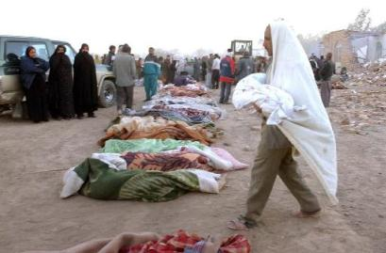

The photo below depicts earthquake damage in the city of Kobe, Japan in the mid-1990s. About 5000 perished in this disaster.
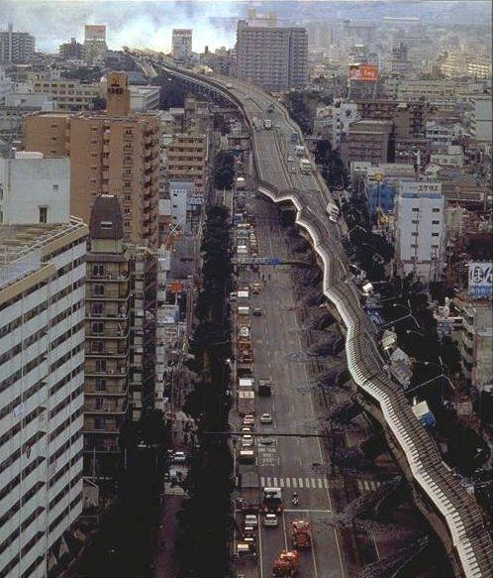

Third, emergency management and disaster policy have emerged as a new domain of public policy. Presidents care about disasters and they regularly make key decisions on the subject (especially in issuing presidential declarations of major disaster and emergency). Congress has legislated heavily on the subject. Lawmakers are also stakeholders in the disaster realm. Government agencies like FEMA, and since March 2003 the Department of Homeland Security, have assumed much higher political profiles.

Interest groups have emerged around the subject. Organizations have formed that represent disaster victims and survivors. Corporations have moved into this realm in a major way. Insurance companies are a key special interest group in the disaster field. Altruistic organizations or volunteer organizations have mushroomed in size and number, all centrally pre-occupied with disaster. I have long said that “disaster policy” is about 10 years behind “environmental policy.” I think that today this gap has closed to within perhaps two or three years.

Our first few classes will offer answers to the questions posed in the opening. Disasters are immensely newsworthy and seemingly ideal objects of television news coverage. Disasters pose political and administrative challenges for government leaders. The media and politics intertwine many aspects of disaster management.

Disasters and emergencies involve many questions.

Why and how did the disaster or emergency occur?

Were government officials adequately prepared?

Was the public satisfactorily forewarned?

How did authorities respond before, during, and after the disaster event?

Could loss of life and property have been better averted?

Whose fault is it legally if various forms of disaster loss and damage might have been averted beforehand, but were not?

Is it possible to prevent a recurrence?

Is it possible to mitigate (reduce or alleviate) the scale of loss in the next comparable disaster?

Who pays for restoration and repair after a disaster?

How do federal, state, and local governments organize to address and prevent disasters and emergencies?

What laws apply to disaster preparedness and recovery?

What are the political ramifications of disasters?

How is disaster policy made? What are the politics of disaster?

What theories and concepts help explain disaster as a political and public management phenomenon?

Which agencies handle disasters [inside the U.S.]? Which agencies address disasters [outside the U.S.]?

What role does U.S. domestic emergency management and disaster policy play in U.S. foreign policy?

What special interest groups are involved in disaster policymaking and emergency management?

How do disasters affect the private sector?

Should government disaster activity chiefly address losses sustained by individuals, by private industry and its workforce, or by other state and local governments?

Many of these questions may not seem to be very academic, but I will show you that they very much are. There is an emerging body of scholarship on disasters and emergency management. In this very class, there may be people who will embark on careers as emergency managers. The entire profession of emergency management is growing. Why, because it is very much needed. People want to know how organizations, public and private, function under the stress that disaster and emergencies pose.

Insurance companies want to help minimize their payout of claims by helping and encouraging their policyholders (private corporations, homeowners, and municipal/special district governments) to minimize disaster risks. Many new federal, state, and local laws require corporations, utilities, and homeowners to take specific precautions against disaster threat. Liability and negligence law and cases, as well as huge court settlements, have made public and private authorities aware of the need to prepare for and avert, if possible, disasters and emergencies. After 9/11, the federal government, encouraged by President George W. Bush, established federally supported terrorism insurance, something many banks insist their business customers buy and maintain.

Some of my colleagues in disaster sociology remind me that how people define disaster is subject to change over time. In the 1800s and first half of the 1900s, people and government did not consider a heavily damaging tornado or hurricane as more than a misfortune certain communities might experience. The general assumption was that disaster ravaged areas were expected to recover on their own or with charitable help. Gradually since about 1950, damaging tornados and other disasters have become events that increasingly require state and federal help. Losing a utility service was rarely classified as a disaster fifty years ago, but today when thousands lose a utility service for three hours or more, the incident ratchets toward presidential disaster declaration status.

More than this, disasters and major emergencies require a governmental response. Public warning, search & rescue, evacuation, sheltering, in-kind or cash relief assistance, emergency public works restoration, disaster loans for reconstruction of private facilities or home repair, unemployment assistance, medical aid, and extraordinary interorganizational cooperation are a few essentials of post-disaster aid.

This course will draw on "highly readable" texts, several chapters the professor is working on for his books, and on case studies. The instructor will try to avoid lecturing and instead pose leading questions derived from the readings and he will ask about your views and observations. There is a general core of testable facts and conceptual information in this course, but it will be re-enforced through our review and discussion. Students will be expected to memorize certain terms, laws, dates, etc. provided on posted review sheets. Also, in some sessions each student will be assigned various readings and will be expected to answer specific questions devised by the instructor.

4. Credit Value of Tests, Papers, and Other Requirements

FOR UNDERGRADUATES, there will be four quizzes. I will throw out the quiz with the lowest score and only count your top three quizzes, at 20 points each maximum value. In addition, I am assigning one 18-20 page research paper to undergraduates and several student group presentations. You need to complete an outline of that paper for me by Oct. 26 and you’ll earn a maximum 5 points if it is on time and credit-worthy. Note that 15 percent of your grade comes from points you earn when you come to class and you answer questions I have assigned to you personally via WebCT announcement beforehand.

% OF GRADE ITEM RELEVANT DATE COVERS ASSIGNMENTS

Undergraduates only:
60% QUIZ 1* Sept. 20 From course start
QUIZ 2 Oct. 18 Since quiz 1
QUIZ 3 Nov. 8 Since quiz 2
QUIZ 4 Nov. 29 Since quiz 3

20% PAPER 18-20 pgs DUE DEC 6 (Thurs by email) (5 pm)
5% OUTLINE DUE OCT. 26 (Friday 5 p.m., emailed ok)

15% YOUR PERFORMANCE IN EACH CLASS BASED ON YOUR
ANSWER TO MY PRE-ASSIGNED QUESTIONS (about 2 pts per class) and YOUR PERFORMANCE IN GROUP PRESENTATIONS (may require you to prepare visuals, a PowerPoint presentation, written WebCT Postings, summaries, etc.)

100%** TOTAL for undergraduates

*Each quiz will contain short answer questions and perhaps a short essay question.
**Here is the numeric and alphabetic grading scale used for computation of final grade in the course. A=100-93, A-=92-90, B+=89-87, B=86-83, B-=82-80, C+=79-77, C=76-73, C-=72-70, D+=69-68, D=67-66, D-=65, F=64 or less.

5. Instructor Policies - Research Papers

To clarify some of the above and to be more explicit about grading policy, note the following.

For undergraduates, one research paper is required. For graduate and undergraduate students, I will work with you to assign you a specific research topic for each paper and I will provide you with the format I need you to strictly follow when you write each of your papers. No two students in the course will write on exactly the same topic. I will prepare a research question for you based on what you tell me about yourself and your interests in the opening day survey.

For undergraduates, I am asking you to write one major paper due by email Dec. 6 and it must be at least 18 pages double-spaced. I need the outline of your paper by Oct. 26.

For undergraduates, I am giving you more freedom to address your specific interest in disaster policy in the RESEARCH PAPER. We will develop a researchable question for the paper based on the subject you tell me you would like to address. No two students may have the exact same research paper topic. I need to know what you want to write your paper on no later than Sept. 21 (Fri.), otherwise I will make up a question for you. I need an outline of your second paper by Oct. 27 so that you are able to get your paper researched, outlined, written, proofread and turned in by December 7 (Thursday) at 5 pm. Please note that you need to give me a researched, organized, well written and edited, proofread and polished version of your paper with footnotes/endnotes and a reference page or bibliography of your major sources. Your paper should be at least 18-20 pages. No two students in the course can write on exactly the same topic.

You are welcome to show me draft copies, outlines, research notes, etc. before you turn them in. I only grade the finished paper, and my advice on your preliminary work may help you do a better paper. I will have a WebCT Posting (or WebCT emailed notice) advising you on paper preparation, organization, footnoting, etc.

6. Instructor Policies - Student Presentations

You will be asked to make several in-class presentations, sometimes paired with one or more other students, at some time in the semester. The survey you completed the first day will help me make assignments. The point of this is to give you a chance to present the major points of a particular disaster case study, article or chapter.

You are free to use laptops, overhead transparencies, the blackboard, charts, figures, WebCT Postings, and no more than 10 minutes of videotape when you make in class presentations. You can ask the instructor or the class questions and we can ask you questions too during your presentation. Some of our work may involve simulations or role playing exercises.

7. Instructor Policies - Missing a Quiz

You might ask yourself, what if I miss a quiz? I am counting the top three quiz scores you earn out of six quizzes (15 pts max per quiz). If you take all four quizzes, you earn extra credit for the fourth quiz (up to 10 pts. max.), which is added to your final course numeric grade. If you miss ONE quiz, I will count it as the one to be dropped of the four and you do not need a written medical excuse authorized by the Dean. If you MISS TWO OR MORE quizzes, you’ll have to makeup the one(s) you missed beyond the first one and you will need an official excuse approved by the Dean’s office for the second absence. For two, and with an official medical excuse, you will have to take a three hour exam in the Dec. exam week. No makeup quizzes or exams will be given to anyone who does not provide the instructor a written excuse from the University.

8. Instructor Policies – Participation, Attendance, Classroom Behavior

I would appreciate it if you could attend all classes, but I understand that there may be reasons why you miss one or at most two sessions. Please note that a portion of your grade stems from your answer to the formal question I pose to you before each class. So you can expect to lose about two points for each class you miss. Of course, if you are an undergraduate and you are absent on the day of a quiz you must comply with the policies under “Missing a Quiz.” Anyone who misses four sessions will fail the course. Leaving class early constitutes a full class absence. Late comers to class are recorded as absent, with exception of first late arrival.

Laptop policy: You are welcome to bring and use a laptop in class but you are asked to use it only for class purposes. I reserve the right to observe whatever you have on your laptop screen during my classes. If you are answering or sending emails or doing non-class related things, I will ask you to leave the class session.

Cell phone policy: please turn off your cell phone when you come to class. If you answer cell calls during class or send out text messages on your cell phone during class, I will ask you to leave and you get no attendance credit for that session. Absolutely no cell phones allowed during tests, if I see one in plain sight during the test I take your phone and your test is finished at that point.

This is a modest sized class. I would like to handle the course as a seminar. I will be calling the roll until I know you. I may even take your photograph. This is a WebCT assisted course and so I will regularly post a list of questions and names. When you see your name on the list you will be expected to answer the question I have assigned you in the next class. You may only have a day or so to prepare, so get in the habit of checking WebCT student email.

I want you to know that I appreciate your class participation. The better prepared you are for each session, the more interesting the course will be for all of us. Participation credit also comes in presentation work you are expected to do. A portion of your course grade is earned from your presentation efforts over the semester.

9. Instructor Policies - Instruction Methods and WebCT

I will be posting on the WebCT site for this course some selected reading assignments and I will WebCT Posting some in class a week in advance. Many of these reading materials I have produced myself. Sometimes, I will forward outlines of what I am to cover in each class, before each class meets, again using WebCT. Please note that this course syllabus is subject to change during the semester. I do this based on what you tell me your interests are and based on what I think is the best arrangement of readings I can provide.

Each UD student should have an email account from the University. I suspect you all have one now. You must have a current email account and you must be linked to the University computing system to receive email I send the class. If you have an off-campus email account (like AOL etc.) it is possible to get help from the Help # (831-6000) so you can connect to the UD system [best hours to phone them are between 8:30 am and 3:30; no humans man the phones after 4 pm weekdays and no one answers the phones Saturdays or Sundays].

The Registrar uses only your campus email address and this connects you to and places you inside the WebCT site of this course. If your off-campus email address is not connected to your on-campus email address you will not get my WebCT email, nor will you be able to access the WebCT site for this course. One more time, if you think your on-campus email address in not linked to your off-campus email address, go to work on getting them connected immediately.

I place a great many course materials on the WebCT site for this course. You should get in the habit of checking the WebCT homepage of this course for announcements and new postings every day or so over the spring semester. If you do not see the question I have assigned you before a class, this will put you at a disadvantage in class and potentially result in your loss of credit. I try to key you into what I have added to the course web page in the paragraph under the banner title of the course.

In this course, you will sometimes have to take class notes. If I go too fast, please ask me to slow down. There will be about 8 sessions in which we will view videos relevant to the disaster subjects we are examining at the time. However, these videos will never run for the full class (usually an hour maximum) and we may interrupt many of them to discuss various things. I am immensely grateful to any of you able to help me with the audio-visual mechanics of using PowerPoint, running videos, and linking to the web from the classroom podium. Since this is an evening class, Gore Hall audio-visual helpers may not be available when we need them.

In addition, you are welcome to visit me at my office [459 Smith] if you have problems or questions. Please note from the cover page that my hours are Tues 3:30-5 p.m. and Wed. 2-5 p.m at 459 Smith (phone there is 831-1943). It is always better to phone to let me know you are coming even if you are stopping by during office hours (I have a great many meetings sprung on me with little or no warning and they sometimes conflict with office hours). If you try to see me outside office hours, and I am in, I’ll probably be happy to talk with you. However, because I teach other classes and have other obligations on and off campus, it will be difficult to find me at 459 Smith outside office hours.

You can leave messages by calling 831-1943 or email me through WebCT. You can email to my personal email address sylves@udel.edu but I prefer you email inside WebCT because outside WebCT I may erase your message assuming it is spam.

I will never lecture for a 3 hour session. We engage in a dialogue, I ask you either pre-assigned questions or I ask you questions extemporaneously. We will have some presentations by you and some by the graduate students. Certain nights will feature video that complements course work. We do not always talk about every assigned reading but you are expected to come to class prepared to discuss the readings of that night.

10. Academic Honesty and Integrity

The University asks that each professor state his or her policies on academic honesty and dishonesty.

I expect you to do your own work in the course on the quizzes and the research papers. I expect you to be able to document and show me the sources and notes of your research papers. You may consult Internet sources but always furnish me attribution of the full web address in the footnotes or endnotes. However, over-use of Internet sources uncited, or downloading of work done by others and turned in as if it is your own, is forbidden and you will lose the full credit of the work you submit – you have the right to appeal to the judicial system. I use an essay verification system which checks every paper for plagiarism. If your paper is plagiarized (20% or more) you fail the course.

In fall 2002, two students in this course at that time submitted papers they had obviously purchased from on-line paper mills. As I said, I use an essay verification search engine, so don’t even think about buying or copying someone else’s work. You can protect yourself from allegations of cheating by properly citing passages you use from other sources, including Internet on-line sources, and by following the instructions I give you for research paper work. Also, I will expect you to write your paper on the basis of a format we agree to in advance and I expect your paper to draw from books and other readings assigned in the course, as well as from other sources. Also, if you are unable to explain to me the content of your paper and if you have no notes or materials to show me what you used in preparing successive drafts of your paper, we will have problems (likely course failure).

If I observe you reading answers from another student’s test during a test, you will forfeit the full credit of that test though you may appeal through the University judicial system if you so choose. I ask you to cooperate with your classmates on teams and in preparing for your presentations.

Do’s and don’ts in this class

❖ Please come to class on time. If attendance has been taken before you arrive you will be considered absent for the class. Frequent late arrival is rude to the instructor and your fellow students.

❖ Please let the professor know before class begins if you have to leave class early. Failing to do so may result in loss of participation credit. I deeply appreciate people who let me know at the start of class that they have to leave early.

❖ Picture yourself giving a talk to an audience or performing on a stage. You read audience body language to determine if they seem to be grasping what you are presenting or responding positively to your performance. You’re nervous, you want to do a good job, and you always want to make a good impression with all of those present. Now imagine that various people in the audience for no apparent reason seem to get up and leave the room during your talk. They sometimes (but not always) return later. You cannot help but conclude that they do not think much of you or your talk. They don’t care what affect their leaving the room has on the audience. Trust me, students getting up and down during class to leave and return to the room drives your professors “nuts” and I’m just like the rest of them. Unless you’re 80 year’s old and you have an incontinence problem, please “no in and out during class.” However, you should feel free to ask me for a short full class break during class if you need one. I can relate to your need for a break once and a while, plus I’ll also appreciate that you are a considerate person.

❖ Please do not bring food to class and no eating food in class. Coffee, sodas, or water are okay but be warned you may be moved around in some sessions and you need to avoid spills. If you arrive late with a big frappachino, the professor gets to drink half.

❖ Please turn off all cell phones in class. During a test, if you bring a cell phone you will have to deposit it on the instructor’s table and you can retrieve it when the test is over. No text messaging in class, please.

❖ Please no laptops in class unless the instructor asks people to bring their laptops for a certain session. Laptops are often a distraction as too many people are not using them for course work.

❖ Okay, you’re worried about how to take notes in the course without a laptop. Feel free to write on a pad of paper. For many classes the instructor will provide handouts of what is covered via PowerPoint. Sometimes the PowerPoint and other notes will be made available through WebCT usually after, but sometimes before, class.

11. Advice and help from the professor

Any student having difficulty with the course requirements or materials should discuss his or her problems with the instructor. The instructor is available during regular office hours and by appointment. He can also be reached by phone in the office or at home and by email.

Dr. Rick Sylves
Office 459 Smith Hall
Phone: 831-1943 (accepts voicemail)
Fax: 831-4452 (Be sure “Sylves” appears on sent cover sheets)
Email sylves@udel.edu
Fax (302) 831-4452
Office Hours: 3:30-5:30 pm Tuesdays and Wednesdays, and, by appointment.

12. READING ASSIGNMENTS

Please be aware that there will be additions and deletions of items from the reading list during this course. Make sure you use the latest version, which can always be found on the course WebCT site under “Course Outline.” Also note that the Professor has written extracts of some of the optional readings and he has made them available on the course WebCT homepage.

AUG 30 #1: Introduction, course objectives and requirements.
(Thurs.)
A get acquainted session with brief lecture and discussion. I will ask you to complete a survey of your interests. I provide a presentation and preview.
-----------
SEPT 6 #2 Remembering 9/11 Open Discussion and Intro to Disaster Management
(Thurs.)
READ
Haddow, George D. and Bullock, Jane A. 2nd Ed. Ch. 1 “The Historical Context of Emergency Management,” pp. 1-18.
Kettl, Preface and Ch. 1, “Stress Test,” pp. 1-17 and Ch. 2, “The Coordination of Dilemmas,” pp. 18-36.

(WebCT Posting) Read Sylves, Ch. 9, “The 9/11 Victim’s Compensation Fund: Master Model vs. Conventional Disaster Relief Model.” (In our in class debate an undergraduate group will debate a graduate group, and a three judge panel (2 undergraduates and 1 graduate student, will serve as judges and decide the outcome). The graduate team will argue in favor of the master model and the undergraduate team will argue in favor of the conventional model.

OPTIONAL READING

The 9/11 Commission Report, Ch. 9, “Heroism and Horror,” pp. 278-324.

-----------
SEPT 13 #3 Fundamentals of U.S. Emergency Management and Preparedness
(Thurs.)

READ
WebCT posting: Sylves, Ch. 1, “Disaster Management in the U.S.A.: Some Fundamentals.”

Haddow, George D. and Bullock, Jane A. 2nd Ed. Ch. 2, “Natural and Technological Disasters and Risk Assessment,” pp. 19-56 and Ch. 6, “The Disciplines of Emergency Management: Preparedness,” pp. 157-194.

Kettl, Ch. 3, “The Reshaping the Bureaucracy,” pp. 37-60.
-----------
SEPT 20 #4 Disaster Response; Human Caused Disaster,
(Thurs.)
QUIZ #1 will be given in last hour of class.
READ
(WebCT Posting) Sylves, Ch. 2, “Disaster Managers and Theories of Policy Implementation.”

Haddow, George D. and Bullock, Jane A. 2nd Ed. Ch. 4, “The Disciplines of Emergency Management: Response,” pp. 77-130.

Kettl, Ch. 4, “The Federalism Jumble,” pp. 61-80.

(graduate students only)
Birkland, Ch. 1, “Theories and Models of Policy Change and Learning,” pp. 1-30 and Ch. 2, “September 11, Learning and Policy Change,” pp. 31-60.

---------
SEPT 27 #5 Presidential Disaster Declarations over 50 Years
(Thurs.)

READ

(WebCT Posting) Sylves, Ch. 3, “Historical Trends in Disaster Management,” and
Ch. 4, “Understanding Disaster Policy through Presidential Disaster Declarations.”

Miskel, Ch. 2, “When the System Fails,” pp. 23-38.

Group #1: Miskel, Ch. 4, “Hurricane Agnes, Three Mile Island, and the Establishment of FEMA,” pp. 57-76.
Group #2: Miskel, Ch 5, “Hurricane Hugo and Andrew,” pp. 75-90.
Group #3: Miskel, Ch. 6, “Hurricane Katrina,” pp. 91-108.
Group #4: Miskel, Ch. 7, “Two Other Models,” pp. 109-122.
Group #5: Miskel, Ch. 8, “Conclusions and Recommendations,” pp. 123-142.

-----------
OCT 4 #6 Managing Disasters and Disaster Recovery,
(Thurs.)
READ

Haddow, George D. and Bullock, Jane A. 2nd Ed. Ch. 5, “The Disciplines of Emergency Management: Recovery,” pp. 131-156.
Kettl, Ch. 5, “The Political Costs of Managing Risk,” pp. 82-101.

Coppola, Ch. 1, “The Management of Disasters,” pp. 1-30 and Ch. 7, “Recovery,” pp. 299-336.
----------

OCT 11 #7 Disaster Mitigation and Preparedness, Vulnerability Assessment, Risk Management
(Thurs.)
READ
(WebCT Posting) Sylves, Ch. 5, “The Role of Scientists and Engineers.”

Haddow, George D. and Bullock, Jane A. 2nd Ed. Ch. 3, “The Disciplines of Emergency Management: Mitigation,” pp. 57-76.

Birkland, Ch. 4, “Learning from Earthquakes and Hurricanes,” pp. 103-156.

Coppola, Ch. 4, “Mitigation,” pp. 175-208.

(graduate students only)
Birkland, Ch. 3, “Learning from Aviation Security,” pp. 61-102.

RESEARCH PAPER 1 (graduate students only) DUE BEFORE 5 PM Friday Oct. 13.
--------
OCT 18 #8 Civil Security Issues (graduate student presentations on)
(Thurs.) QUIZ #2 will be given in class.
READ
(WebCT Posting) Sylves, Ch. 7, “Civil Military Relations and National Security.”

Miskel, Ch. 3, “Disaster Relief and the Military,” pp. 39-56.

---------
OCT 25 #9 Special Issues, U.S and International
(Thurs.)
READ
(WebCT Posting) Sylves, Ch. 6, “Intergovernmental Relations in Disaster Policy.”

Haddow, George D. and Bullock, Jane A. 2nd ed. Ch. 7 “The Disciplines of Emergency Management: Communications,” pp. 195-218.

Groups #1, #2: Coppola, Ch. 2, “Hazards,” pp. 31-112.
Groups #3, #4: Coppola, Ch. 3, “Risk and Vulnerability,” pp. 113-174.

(graduate students only)
Birkland, Ch. 5, “Disasters, Learning, and the Possibility of Change,” pp. 157-196.

---------
NOV 1 #10 International Perspective and the Globalization of Disasters
(Thurs.)
READ
(WebCT Posting) Sylves, Ch. 8, “Globalization of Disasters.”

Group #1: Coppola, Ch. 5, “Preparedness,” pp. 209-250.
Group #2: Coppola, Ch. 6, “Response,” pp. 251-298.
Group #3: Coppola, Ch. 8, “Participants, Governmental Disaster Management Agencies,” pp. 337-386.

---------
NOV 8 #11 / Foreign Disaster Management and the Linkage to U.S. Disaster Policy/Foreign Policy Link to Homeland Security.

(Thurs.) QUIZ #3 will be given in class.
READ

Haddow, George D. and Bullock, Jane A. 2nd Ed. Ch. 8, “International Disaster Management, Case Study,” 219-254.

(WebCT Posting) Chapter 8: Foreign Disasters and the Globalization of U.S. Disaster Policy and Management

---------

NOV 15 #12 Homeland Security as the New Civil Defense/International Disaster
(Thurs.)
READ

Haddow, George D. and Bullock, Jane A. 2nd ed. Ch. 9, “Emergency Management and the New Terrorist Threat, pp. 255-325.
Kettl, Ch. 6, “Balancing Liberty with Protection,” pp. 101-122.

Group #1, #2: Coppola, Ch. 9, “Participants: Nongovernmental Orgs,” pp. 387-450.
Group #3, #4: Coppola, Ch. 10, “Participants: Multilateral Orgs and Int Financial Institutions,” pp. 451-524.
Group #5: Coppola, Ch. 11, “Special Considerations,” pp. 525-538.

---------

Nov 22, no class meeting due to Thanksgiving Break

---------
Nov 29 #13 Future of Emergency Management. Course evaluations, and last meeting day. QUIZ #4 will be given in class.
(Thurs.)
READ

Haddow, George D. and Bullock, Jane A. 2nd ed. Ch. 10, “The Future of Emergency Management,” pp. 327-336.
Kettl, Ch. 7, “Gauging the Stress Test,” pp. 123-143.

(WebCT Posting)

(Dec 6 Thurs.) No class session. RESEARCH PAPER DUE BEFORE 5 PM via email.

----------
Thank you for taking this course. It was not possible for us to cover every topic you may have founding interesting, but I hope the research papers and readings gave you a chance to read beyond our required assignments. Let me know if I can be of help to you in your career. Best wishes, Dr. Sylves

